**COMMON MARKET FOR EASTERN AND**

**SOUTHERN AFRICA**

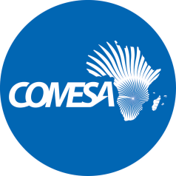

**السوق المشتركة للشرق والجنوب الأفريقى**

###### MARCHE COMMUN

**ADDENDUM NO. 2**

**TENDER TITLE:**TENDER FOR SUPPLY AND DELIVERY OF EQUIPMENT FOR SEYCHELLES INCUBATION CENTRE

**PROC REF No:** CS/IAD/1400/2(035 – 22) PM-ab

All PROSPECTIVE **BIDDERS** are hereby notified that COMESA Secretariat is making some changes to the Standard Biding Document (SBD) related to the above tender as published on November 11, 2024.

The modifications are as below:

1. **ITB 23.1** **of Section II. Bidding Data Sheet (BDS):**

The narrative in there should read,

The deadline for bid submission shall be 15th January 2025, at 10:00hrs Lusaka time.

1. **ITB 26.1** **of Section II. Bidding Data Sheet (BDS):**

The narrative in there should read,

A public bid opening session shall be conducted upon closure of biding period. The time for Bid opening will be 12:00hrs Lusaka time on 15th January 2025.

All other terms and conditions in the SBD remain the same.

Silver Mwesigwa

**HEAD OF PROCURENT**