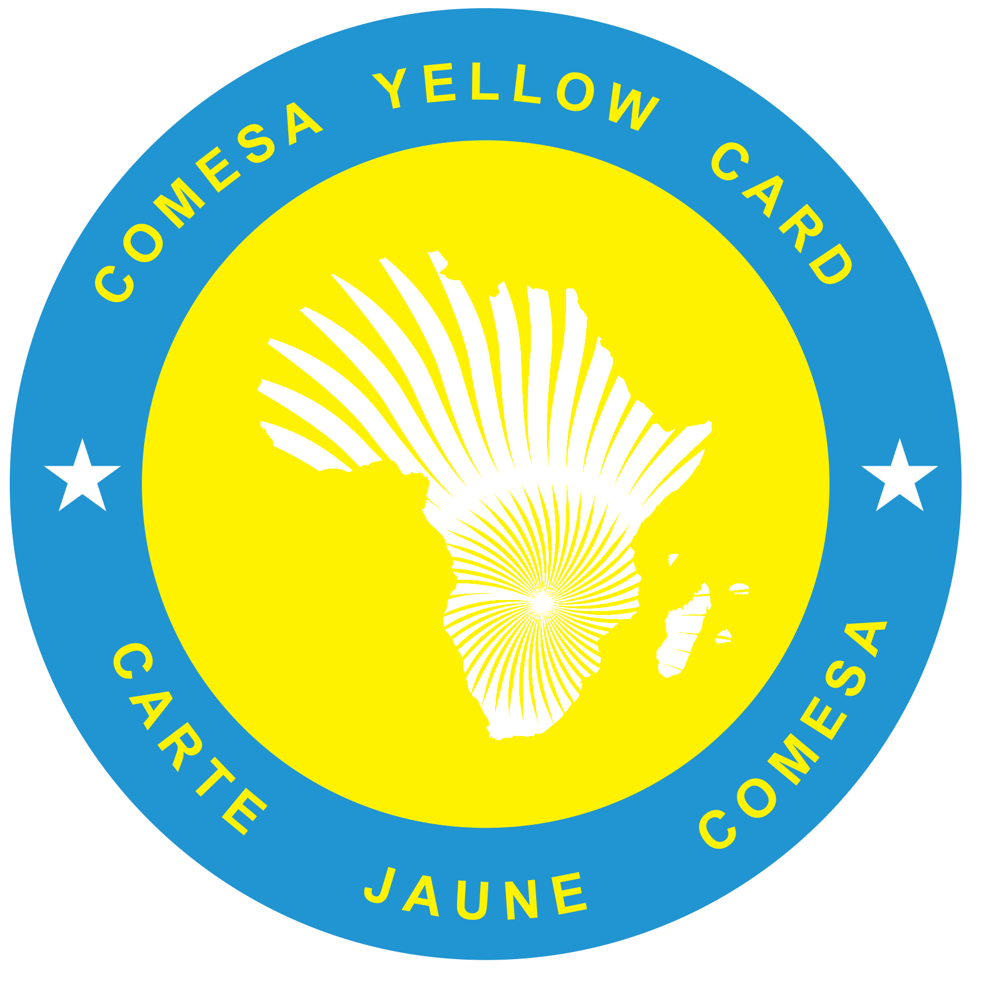

**COUNCIL OF BUREAUX SECRETARIAT**

**Secrétariat du Conseil des Bureaux**

**مجلس للأمانة العامة للبورو**

**OFFICE OF THE CHIEF EXECUTIVE OFFICER**

**Ref:** CBS/HR/PERS/SIE/8/2 Date**:** 21st January 2025

**VACANCY ANNOUNCEMENT FOR THE POSITION OF SENIOR INSURANCE EXPERT UNDER COUNCIL OF BUREAUX SECRETARIAT**

**BACKGROUND**

The Common Market for Eastern and Southern Africa (COMESA) is a regional grouping of twenty-one African States which have agreed to cooperate in the development of their respective economies through regional integration and trade development. COMESA’s regional integration strategy is based on the setting up of regional policies aimed at transforming the region into a single market and facilitating the integration of its member states into the world economy.

# The Preferential Trade Area (PTA), COMESA's predecessor; established, by a Protocol, a compulsory Third-Party Motor Vehicle Insurance (Yellow Card) Scheme to provide at least a minimum guarantee, as those required by the laws in force in the territories of the parties to the Protocol, when the vehicle insured is transiting the territories of other contracting parties thereby facilitating the smooth movement of vehicles in the Region and ensure payment of compensation to road accident victims injured by the transiting vehicles.

**JOB DESCRIPTION: SENIOR INSURANCE EXPERT**

**Job Title** : SENIOR INSURANCE EXPERT

**Grade** : P4

**Duty Station** : Lusaka

**Report To** : Chief Executive Officer – Council of

Bureaux Secretariat

**Basic Salary Scale :** COM$ 63,135.00 – COM$ 75,953.00 per annum.

1. **JOB PURPOSE**

The **Senior Insurance Expert** will be responsible for the management of an effective implementation of the COMESA Yellow Card Scheme under the Council of Bureaux Secretariat. She/He will preside over the implementation of policies, procedures, and guidelines for the Scheme. She/He shall ensure proper implementation of Yellow Card Scheme in relation to administrative, technical, risk management and strategic activities.

1. **MAIN DUTIES AND ACCOUNTABILITIES:**

Under the directsupervision of the Chief Executive Officer**,** you shall be responsible for the following duties*:*

1. Implement and coordinate the Scheme in the Member countries,
2. Initiate and implement measures and changes to improve the technical, legal, financial and administrative instruments,
3. Provide advisory services and technical assistance to members in the implementation and administration of the Yellow Card Scheme,
4. Prepare and undertake inhouse training of technical staff in the Council of Bureaux Secretariat
5. Prepare performance reports on activities and operations of the Scheme,
6. Assist in organising and servicing regional meetings and workshops,
7. Organise, prepare and service technical Sub-Committee meetings of the Management Committee,
8. Assist the Chief Executive Officer in servicing Management and Council of Bureaux Meetings,
9. Assist with stakeholders’ engagement and the management of agreed policies and activities,
10. Assist with the implementation of the Yellow Card Scheme strategic plan, evaluation, and monitoring of Key Performance Indicators,
11. Oversee the negotiation, and renewal of the Yellow Card Scheme reinsurance Pool structure, in liaison with the Pool Managers,
12. Conduct studies to enhance the efficiency and effectiveness of the operations of the Yellow Card scheme,
13. Collaborate with stakeholders to define and provide business requirements for enhancements to the Digital Yellow Card (DYC) system, ensuring alignment with operational needs and user expectations.
14. Provide data-driven insights by analysing statistical data from the Digital Yellow Card system related to underwriting, claims, and premium collection, to optimize operations and address risk factors.
15. Facilitate the administrative process of executing missions for statutory meetings and/or workshops,
16. Any other related duties that may be assigned by your supervisor from time to time.
17. **PERSON SPECIFICATION**

**(a) Education / Professional qualifications**

The candidate must

* Have at least a master’s degree in either Insurance and/or Risk Management, Quantitative Studies, Commerce or Business Studies. A holder of internationally recognized professional Insurance qualification e.g., Associateship of the Chartered Insurance Institute (ACII) /Fellow of the Insurance Institute of South Africa (FIISA). Equivalent and internationally recognized qualifications for Francophone countries should be considered.
* Be a national of a COMESA Yellow Card Member country.

**(b) Experience**

* Have at least 10 years’ experience in the Insurance field; five of which should be at Senior Management level. Exposure in working in international or intergovernmental organizations would be an added advantage.
* Have experience and exposure to regional conference procedures.

**(c) Technical skills**

1. Strong interpersonal and communication skills and the ability to work effectively with a wide range of constituencies in a diverse community.
2. Demonstrated professionalism in re/ insurance and risk management.
3. Excellent planning, organizational, analytical, and decision-making skills.
4. Excellent and proven experience in management, and firm belief in teamwork.
5. Up-to-date computer literacy.
6. **GRADE AND PERIOD**

The Post shall be a Professional Category at P4 level and a regular post under Council of Bureaux Secretariat established professional staff contracts.

1. **REMUNERATION**

Remuneration will be in accordance with the Council of Bureaux Secretariat Conditions of Service for established professional Staff.

1. **LANGUAGES**

Applicants must be fluent in English and a working knowledge of French would be an added advantage.

1. **PERIOD OF APPOINTMENT**

The Senior Insurance Expert will be appointed for a period of four (4) years. She/ He shall be eligible for re-appointment, subject to satisfactory performance.

1. **ELIGIBILITY FOR APPLICATION**

The position is open to qualified applicants who are from the following eligible Yellow Card Scheme Participating Member Countries: Burundi, DR Congo, Djibouti, Eritrea, Ethiopia, Kenya, Malawi, Rwanda, Sudan, Tanzania, Uganda, Zambia, and Zimbabwe.

1. **MODE OF APPLICATION**

All applications MUST be submitted to the National Bureaux of Yellow Card Scheme of the respective Member Countries stated above under Clause H, on the prescribed COMESA APPLICATION FORM which can be accessed at the following COMESA website: <http://www.comesa.int>, Opportunities, COMESA Job Application Forms.

Applications submitted directly to the Secretariat will not be considered and only short-listed candidates will be contacted.

1. **FINAL DATE FOR RECEIVING APPLICATIONS BY YELLOW CARD NATIONAL BUREAUX**

Applications must reach the National Bureau of the respective country by **1st March 2025.**

1. **FINAL DATE FOR RECEIVING APPLICATIONS FROM NATIONAL BUREAUX BY COUNCIL OF BUREAUX SECRETARIAT.**

Both hard and soft copies of the relevant documents of the short -listed candidates by the National Bureaushould reach the address below by **10th March 2025** at least by18.00 hours, Lusaka time.

The Director of Human Resources and Administration

Common Market for Eastern and Southern Africa

COMESA Centre,

Ben Bella Road,

P.O Box 30051,

**Lusaka**

Zambia

Email : [recruitment@comesa.int](mailto:recruitment@comesa.int)