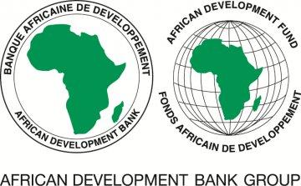

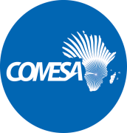

COMMON MARKET FOR EASTERN AND

**SOUTHERN AFRICA (COMESA)**

**CAPACITY BUILDING PROGRAM FOR INFRASTRUCTURE STATISTICS IN TRANSITION STATES**

**GENERAL PROCUREMENT NOTICE**

1. COMESAhas applied for funding from the African Development Fund (ADF) to finance the Capacity Building Program for Infrastructure Statistics in Transition States and intends to apply part of the proceeds to payments for services to be procured under this project.
2. The main objective is to improve the coverage of gender and infrastructure statistics in Transition States, mainly in the power and transport sectors”. It will support NSOs and infrastructure line ministries including ministries responsible for gender, and power and transport institutions by building capacity in gender - responsive infrastructure data collection, validation, and dissemination.
3. The project includes the following: Component 1: Capacity Building and Training; Component 2: Development of Standardized Tools, Data collection, validation, processing and management; Component 3: Knowledge Products generation; and Component 4: Project Management
4. It is expected that procurement of goods, works and services shall be carried out under the Open Competitive Bidding and Simplified Bidding methods for works and goods; and the Quality and Cost Based Selection (QCBS) and Individual Consultants Selection (ICS) methods for consulting firms.
5. The Procurement of Goods, Works and Services, financed by the Bank, will be carried out in accordance with the Bank’s Procurement Policy for Bank Group Funded Operations, dated October 2015 and in line with the provisions stated in the Loan Agreement. Specific procurement notices for contracts subject to open competitive methods are expected to be available **starting March 2025** with notice publications to be issued on the Bank’s and COMESA websites.
6. Interested bidders may obtain further information, and confirm their interest in the above, by contacting the Executing Agency on the address below:

Mr Silver Mwesigwa

Head of Procurement

COMESA Centre

Ben Bella Road

P.O Box 30051

LUSAKA 10101

Zambia

Telephone: +260 211 2297226/29; Web: <http://www.comesa.int> Facsimile: +260 211 227318;

E-mails: [procurement@comesa.int](mailto:procurement@comesa.int); [S.Mwesigwa@comesa.int](mailto:S.Mwesigwa@comesa.int)