COMMON MARKET FOR EASTERN AND

SOUTHERN AFRICA
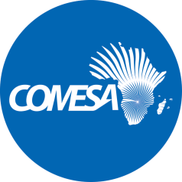
السوق المشتركة للشرق والجنوب الأفريقى

MARCHE COMMUN

ADDENDUM NO. 1

REQUEST FOR EXPRESSIONS OF INTEREST
(CONSULTING SERVICES – FIRMS SELECTION)

COUNTRY: Common Market for Eastern and Southern Africa (COMESA)
NAME OF PROJECT: Inclusive Digitalization for Eastern and Southern Africa (IDEA)
Grant No.: E349-3E

Assignment Title: Consultancy for Development of a Regional Digital Inclusion Action Plan and Associated Draft Regulations and Policies

Reference No.: ZM-COMESA -458146-CS-QBS

Prospective Applicants are hereby requested to take note that:

The Closing date for submission of Expressions of Interests has been extended to FRIDAY 4 APRIL 2025 at 17:00 hours Zambian time.

Please take this as an official notification.

All other terms and conditions remain the same.

Email: procurement@comesa.int; copy DMaimbo@comesa.int

Procurement Expert

