COMMON MARKET FOR EASTERN AND
SOUTHERN AFRICA

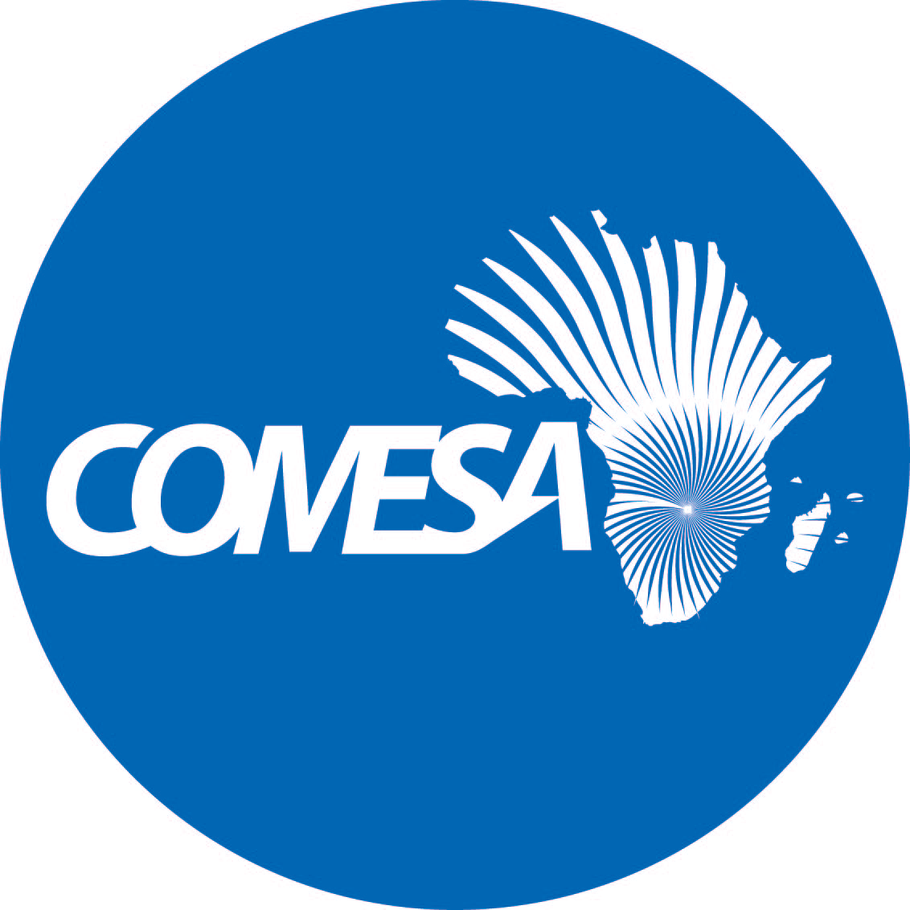

STATEMENT FOR HER EXCELLENCY CHILESHE MPUNDU KAPWEPWE
SECRETARY GENERAL
AT THE OCCASION OF PRESENTATION OF CREDENTIALS

By

H.E Ambassador Abadi Nureldin Abdelrahman Nureldin,
Sudanese Ambassador to the Republic of Zambia and
Now formally Accredited Permanent Representative to COMESA

H. E Ambassador Ashok Kumar,
Indian High Commissioner to the Republic of Zambia and
Now formally Accredited Special Representative to COMESA

H. E Ambassador Du Xiaohui,
Chinese Ambassador to the Republic of Zambia and
Now formally Accredited Special Representative to COMESA

Wednesday, July 13, 2022
COMESA SECRETARIAT, ZAMBIA
Your Excellency,
Ambassador Abadi Nureldin Abdelrahman Nureldin,
Sudanese Ambassador to the Republic of Zambia and
Now formally Accredited Permanent Representative to COMESA

Your Excellency,
Ambassador Ashok Kumar,
Indian High Commissioner to the Republic of Zambia and
Now formally Accredited Special Representative to COMESA

Your Excellency,
Ambassador Du Xiaohui
Chinese Ambassador to the Republic of Zambia and
Now formally Accredited Special Representative to COMESA

My colleagues, the Assistant Secretaries General
Colleagues from Diplomatic Embassies and High Commissions,
COMESA Directors & Heads of Units Present, and
All the Staff from COMESA Secretariat Present,
Members of the media,
Ladies and Gentlemen

I have the honor to welcome Your Excellencies, to Zambia and specifically to the COMESA Secretariat.

Let me also congratulate you, Your Excellencies, upon your new appointment as Permanent and Special Representatives to COMESA and extend my best wishes in your new roles. It is an honor, to have this joint ceremony and I wish to thank you for your cooperation and understanding, to accept our request for combining this event. Indeed, we are now united in our common interest to serve our citizens in the quest for economic empowerment and sustainable development.

Your Excellencies,

As you maybe aware, Sudan is one of our Member States and the Secretariat has been and continues to work very closely with the Member States’ embassies and ambassadors accredited to COMESA, especially those based in Lusaka as well as those outside Zambia but accredited to COMESA. Now that you have formally joined the team of Accredited Permanent Representatives, we look forward to working with you in advancing our cooperation with Sudan.

COMESA has given support to the development of the Member States in various areas. Sudan has been an active participant in COMESA programmes since it joined the organization and as you know, the Headquarters of the COMESA Court of Justice is based in Khartoum, Sudan.

In January 2020, a COMESA Delegation including COMESA institutions, which I lead, visited Sudan to re-engage the leadership in regional integration programmes.
During our visit, COMESA requested Sudan to ratify the COMESA-EAC-SADC Tripartite Free Trade Agremment (TFTA), the ratification is in advanced stages and we need your collaboration for the follow-up on this as the ratification of the Tripartite Agreement by Sudan will bring the number of ratifications closer to 14 which is the requirement for the Agreement to enter into force.

The COMESA Delegation had the opportunity to meet the Prime Minister and different Ministers such as the Minister of Foreign Affairs, Minister of Industry and Trade, Minister of Justice, Governor of the Central Bank and discussed a number of COMESA programmes being implemented in Sudan. These included the COMESA Adjustment Facility (CAF) which has made available a total of Euro 2,077,004 to Sudan for the period 2017 to 2020 for the implementation of regional projects.

COMESA provided technical support to the government in reviewing and development of the legal and institutional frameworks for the Sudan/Ethiopia One Stop Border Post.

Your Excellency, in addition, Under the customs sector, the Authorized Economic Operators (AEO) Programme had been rolled out in 14 Member States of COMESA including Sudan. Other support extended to Sudan include;

- Technical Support to the EUROTRACE trade statistics database system,

- The Ecofish program through which COMESA supported the implementation of programs Improving economic resilience and food security of the artisan fishers in the northern Sudanese Red Sea Coast-SOS Sahel Sudan.

- Under the 11th EDF Trade Facilitation Programme, we supported the establishment of National Task Forces in adoption of good practices in food import control and in domestic food facility inspection.

- In March 2021, COMESA launched the 50MAWSP Platform in Sudan.

Your Excellencies, regarding our cooperation with India:

As you may be aware, India and COMESA signed an MoU in 2003. During our first meeting with H.E Ambassador Ashok Kumar earlier this year, we agreed to revise the said MoU and re-launch the cooperation between India and COMESA to take into account new developments and cooperation aspects. I call upon our technical teams to expedite the process of coming up with the revised MOU.

Your Excellency, COMESA’s top exports to India between 2019-2020 have been dominated by manufactures, followed by fuels, ores and minerals, food, other products, agricultural raw materials. The major COMESA imports from India are refined petroleum products, rice, pharmaceuticals and steel. During the COVID-19 pandemic, COMESA imported products from India pharmaceutical, and represented 19% of the source market for COMESA. COMESA’s imports from India however decreased from US$ 11.4 billion to US$ 9.4 billion between 2019-2020.

Your Excellency, allow me to inform you that India has been and continues to be one of our strong development partners. You will recall that COMESA participated in the 1st and 2nd India-Africa Forum Summit in 2008 and 2011. As well as the India-RECs Meeting in 2011, in which a cross-section of Indian investors and entrepreneurs met with the COMESA delegates to discuss opportunities in the region, to learn about the growing market size which currently stands at nearly 583 million people.

Your Excellency, during your visit, you requested COMESA to organize a COMESA Business/trade visit to India comprising business delegates, including the private sector and respective Member States Ministries and Agencies. Let me assure you, that we thank you for this proposal and we still working on it with our respective insitutions such as the COMESA Business Council and Regional Investment Agency, and we shall inform you the progress in due course. There are indeed more opportunities to come out of our continued and even stronger cooperation between COMESA and India, taking into account that COMESA is the largest REC in Africa, spanning from Tunisia in the north to Eswatini in the South.

Regarding our cooperation with China:

Your Excellencies,
China and COMESA have a long history of partnership and cordial relations. China was ranked as the region’s third export destination market in 2020. Exports to China, however, dropped to USD 9.5 billion in 2020 from USD 11.2 billion in 2019. Similarly, the value of Imports from China declined from USD 35 billion in 2019 to USD 26 billion in 2020.

Your Excellency, allow me to inform the meeting, that China and COMESA have a joint office based in Hangzhou, called International Centre on Small Hydro Power (ICSHP). In 2020, China through the ICSHP donated 5,000 facemasks to COMESA, to support the member states in the fight against the COVID19 pandemic.

On capacity building, China supported the scholarship of three engineers from Egypt, Libya and Sudan in 2019 for the Hohai University Master Programs for Water Conservancy Professionals.

As you may be aware, COMESA and China, through the Ministry of Water Resources, signed a cooperation agreement regarding the exchange of visiting scholars programme. The collaboration aims to assist and support COMESA’s development and deepen the China-Africa cooperation. We convey our appreciation through you, Your Excellency, to the Government and people of China for the support.

Your Excellencies,

As I conclude, allow me to once again congratulate you upon your appointments and wish you success in your tour of duty. I want to assure you, that you can count on our full support and feel free to contact myself and or any of my colleagues for any assistance that you may require from the Secretariat.

I am therefore, pleased to accept your letters of credence and formally accredit you to the list of Permanent and Special Representatives to COMESA, respectively.

I thank you for your kind attention.

