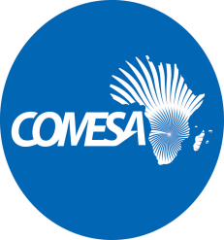 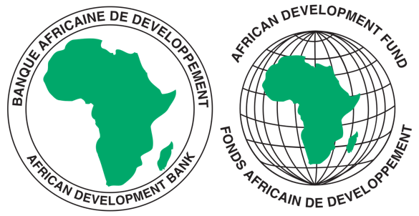

COMMON MARKET FOR EASTERN AND SOUTHERN AFRICA

**REQUEST FOR EXPRESSIONS OF INTEREST**

**SELECTION OF INDIVIDUAL CONSULTANTS**

REFERENCE NUMBER: CS/CSTRPSD/09/05/km

**CONSULTANCY SERVICES TITLE**: CONSULTANCY SERVICES TO CONDUCT A STUDY AND DEVELOP A POLICY FRAMEWORK THAT PROVIDES GUIDELINES AND PROMOTES GENDER EQUITY AND EQUALITY IN THE PHARMACEUTICAL INDUSTRY

**PROJECT NAME:** COMESA SUPPORT TOWARDS REGIONAL PHARMACEUTICAL

SECTOR DEVELOPMEMNT

**SECTOR:** INDUSTRIALISATION/PHARMACEUTICAL INDUSTRY

**GRANT NUMBER:** 2100155042033

**PROJECT ID:** P-Z1-BB0-008

1. This Request for Expression of Interest follows the General Procurement Notice for this Project that appeared in UN Development Business (UNDB online); on the African Development Bank’s Internet Website ([www.afdb.org](http://www.afdb.org)) and the COMESA Secretariat Website ([www.comesa.int](http://www.comesa.int)) on 10 February 2022.
2. The COMESA Secretariat has receiveda grant from the African Development Fundtowards the implementation of the COMESA Support Towards Regional Pharmaceutical Sector Development Project. The COMESA Secretariat intends to apply part of the proceeds of the grant to recruit an Individual Consultant **to Conduct a Study and Develop Policy Guidelines to Promote Gender Equity and Equality in the Pharmaceutical Industry.**
3. The main objective of this consultancy is to develop a Policy Framework and associated Monitoring and Evaluation Plan to promote gender equity and equality in the pharmaceutical industry in the COMESA region. The consultancy will focus on the pharmaceutical industry in the COMESA region while leaning heavily on other successful and relevant gender initiatives and frameworks to develop a context specific policy framework.
4. The Consultant is expected, among other things, to:
5. Develop an appropriate methodology for the assignment and outline it in the inception report;
6. Review the international, regional and sub regional policy frameworks on gender equity and equality in the pharmaceutical industry to identify bottlenecks and strengths;
7. Conduct a comparative analysis and benchmarking exercise with other successful frameworks and initiatives outside the region to identify gaps in policies and performance as well as draw reform lessons;
8. Analyse the current policy frameworks and practices in the COMESA Member States on gender equity and equality in the pharmaceutical industry to identify gender gaps and opportunities for gender integration and mainstreaming.
9. Develop an appropriate Regional Gender Policy Framework and Monitoring and Evaluation plan for the Pharmaceutical Industry to guide the region for the next 10 years.
10. Facilitate stakeholder engagements to validate the Policy Framework.
11. The COMESA Secretariat now invites eligible candidates to indicate their interest in providing these services. Interested Individual consultants must provide information indicating that they are qualified to perform the services (i.e., description of similar assignments, experience in similar conditions and availability of appropriate skills and qualifications).
12. The individual consultant should have significant in-depth expertise and knowledge of gender policies and initiatives plus a good understanding of the medical and pharmaceutical industry in Africa and the COMESA region.
13. Expressions of Interest shall be evaluated as follows:
14. Applicant’s Educational qualifications 30 points
15. Relevant Experience and skills 60 points
16. Experience in the African Region 10 points
17. Eligibility criteria, establishment of the short-list and the selection procedure shall be in accordance with African Development Bank’s “Procurement Framework for Bank Group Funded Operations” dated 2015, which is available on the Bank’s website at: <https://www.afdb.org/en/projects-and-operations/procurement/new-procurement-policy>. The Consultant will be selected under the Individual Consultant Selection (**ICS**) method.
18. Detailed description of the assignment including Terms of Reference defining the minimum technical requirements for the services can be downloaded free of charge from the COMESA Website on the link alongside this notice: [www.comesa.int](http://www.comesa.int)
19. Additional requests for information and clarifications can be made until 5 working days prior to the deadline at the following addresses: E-mail: [kmiti@comesa.int](mailto:kmiti@comesa.int); [s.mwesigwa@comesa.int](mailto:s.mwesigwa@comesa.int); [wsiduna@comesa.int](mailto:wsiduna@comesa.int)
20. **SUBMISSION OF APPLICATIONS**

Expressions of Interest bearing the subject: **“Consultancy Services to Conduct a Study and Develop a Policy Framework that provides Guidelines to promote Gender Equity and Equality in the Pharmaceutical Industry”** must be submitted as **ONE FILE** using the Expression of Interest Forms annexed to the Terms of Reference and must be emailed to the following addresses: E-mail: [kmiti@comesa.int](mailto:kmiti@comesa.int); [s.mwesigwa@comesa.int](mailto:s.mwesigwa@comesa.int); [wsiduna@comesa.int](mailto:wsiduna@comesa.int) **by 7 June 2024**

NB: Physical submission of EOIs will not be accepted.