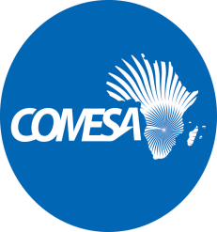 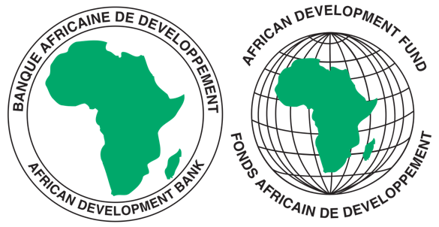

**REQUEST FOR EXPRESSIONS OF INTEREST**

**(CONSULTING SERVICES - FIRM)**

COMMON MARKET FOR EASTERN AND SOUTHERN AFRICA

**PROJECT NAME:** COMESA SUPPORT TOWARDS REGIONAL PHARMACEUTICAL

SECTOR DEVELOPMEMNT

**SECTOR:** INDUSTRIALISATION/PHARMACEUTICAL INDUSTRY

**GRANT NUMBER:** 2100155042033

**PROJECT ID:** P-Z1-BB0-008

1. This Request for Expression of Interest follows the General Procurement Notice for this Project that appeared in UN Development Business (UNDB online); on the African Development Bank’s Internet Website ([www.afdb.org](http://www.afdb.org)) and the COMESA Secretariat Website ([www.comesa.int](http://www.comesa.int)) on 10 February 2022.
2. The COMESA Secretariat has receiveda grant from the African Development Fundtowards the implementation of the COMESA Support Towards Regional Pharmaceutical Sector Development Project intends to apply part of the proceeds of the grant to engage a consulting firm **to conduct an assessment of the Capacity and Competence for Testing and Certification of Pharmaceutical Products in the COMESA Region.**
3. The overall objective of the consultancy is to assess capacity and competence for testing and certification of pharmaceutical products in the COMESA region, recommend capacity building initiatives to address Substandard and Falsified Medicines Products (SFMP), quantify and cost key infrastructure needed.
4. The consulting firm will undertake a comprehensive assessment on testing and certification capacity in the COMESA in consultation with relevant stakeholders in the sector (eg AUDA NEPAD, USAID PQM plus, WHO) and taking into consideration current initiatives within NMRAs such as WHO Benchmarking with the following specific objectives:
5. Assess the capacity and competence of laboratories involved in testing and certifying pharmaceutical products at National Medicines Regulatory Authorities (NMRAs) in line with relevant certification standards (eg ISO 17025 or WHO PQ) focusing on laboratory infrastructure, equipment, expertise etc.
6. Identify areas of capacity-building to rectify identified needs and fortify NMRA laboratory capabilities
7. Recommend interventions to improve reliability and accuracy while ensuring compliance with international standards, thereby combatting counterfeit pharmaceuticals, and promoting public health and safety.
8. Implement selected relevant interventions to address identified gaps, eg capacity building, technical assistance, and guidance on equipment procurement, aimed at enhancing regulatory oversight and quality assurance capabilities to combat the circulation of sub-standard and counterfeit pharmaceuticals.
9. The COMESA Secretariat now invites eligible consultancy firms to indicate their interest in providing these services. Interested consultants must provide information indicating that they are qualified to perform the services (brochures, description of similar assignments, experience in similar conditions, availability of appropriate skills among staff, etc.). Consultants may constitute joint ventures to enhance their chances of qualification.
10. Eligibility criteria, establishment of the short-list and the selection procedure shall be in accordance with African Development Bank’s “Procurement Framework for Bank Group Funded Operations” dated 2015, which is available on the Bank’s website at: <https://www.afdb.org/en/projects-and-operations/procurement/new-procurement-policy>. The Consulting Firm will be selected under the Consultants’ Qualification Selection (CQS) method.

Detailed Terms of Reference can be downloaded from the COMESA Website at: [www.comesa.int](http://www.comesa.int). Further information, if required, can be obtained by sending email with requests for clarification during office hours, 0800 - 1700 hours Central Africa Time (CAT). The email should be addressed to the following email address: [Procurement@comesa.int](mailto:Procurement@comesa.int)

1. Expressions of interest must be delivered to the email addresses below by 25 June 2024 at 1600 *hours* CAT and mention “**Consultancy Services to conduct an assessment of the Capacity and Competence for Testing and Certification of Pharmaceutical Products in the COMESA Region.”**

Attn:

Mr. Silver Mwesigwa

Head of Procurement

Common Market for Eastern and Southern Africa (COMESA)

Ben Bella Road

P O Box 30051

Lusaka, Zambia

Tel: 260 211 229725–32

Emails: [s.mwesigwa@comesa.int](mailto:s.mwesigwa@comesa.int); [kmiti@comesa.int](mailto:kmiti@comesa.int);

NB: Physical submission of EOIs will not be accepted.