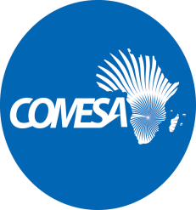 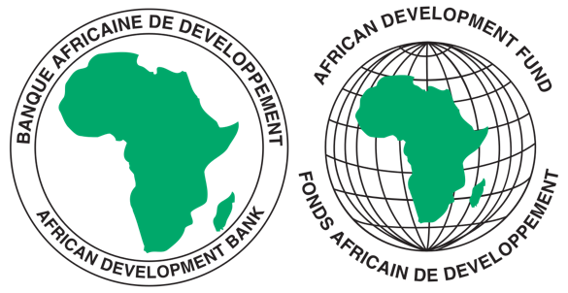

**REQUEST FOR EXPRESSIONS OF INTEREST**

**(CONSULTING SERVICES - FIRM)**

COMMON MARKET FOR EASTERN AND SOUTHERN AFRICA

**PROJECT NAME:** COMESA SUPPORT TOWARDS REGIONAL PHARMACEUTICAL

SECTOR DEVELOPMEMNT

**SECTOR:** INDUSTRIALISATION/PHARMACEUTICAL INDUSTRY

**GRANT NUMBER:** 2100155042033

**PROJECT ID:** P-Z1-BB0-008

1. This Request for Expression of Interest follows the General Procurement Notice for this Project that appeared in UN Development Business (UNDB online); on the African Development Bank’s Internet Website ([www.afdb.org](http://www.afdb.org)) and the COMESA Secretariat Website ([www.comesa.int](http://www.comesa.int)) on 10 February 2022.
2. The COMESA Secretariat has receiveda grant from the African Development Fundtowards the implementation of the COMESA Support Towards Regional Pharmaceutical Sector Development Project and intends to apply part of the proceeds of the grant to engage a consulting firm **to conduct an assessment of (i) Manufacturing Capacity of Pharmaceutical Industry (ii) Pharmaceutical Trade Performance and Supply Chain Integrity in COMESA region, and (iii) the Policy, Regulatory and Institutional Frameworks for Trade in Pharmaceutical inputs and products.**
3. The objectives of the consultancy are:-
4. to assess the capacity constraints in pharmaceutical manufacturing in the COMESA

region.

1. to assess the pharmaceutical input and final products trade performance and supply

chain integrity in the COMESA region.

1. to assess policy, regulatory and institutional frameworks governing trade in

pharmaceutical products and come up with a model policy for trade facilitation in the

region.

1. The COMESA Secretariat now invites eligible consultancy firms to indicate their interest in providing these services. Interested consultants must provide information indicating that they are qualified to perform the services (brochures, description of similar assignments, experience in similar conditions, availability of appropriate skills among staff, etc.). Consultants may constitute joint ventures to enhance their chances of qualification.
2. Consulting firm/organization/entity should have professional experience in pharmaceutical manufacturing, regulatory sciences, pharmaceutical policy and trade at regional/continental level or similar experience outside Africa with a demonstrated 20 years of combined experience in delivering similar and relevant assignments in the sector (list of projects’ details including the scope, location, and clients).
3. Eligibility criteria, establishment of the short-list and the selection procedure shall be in accordance with African Development Bank’s “Procurement Framework for Bank Group Funded Operations” dated 2015, which is available on the Bank’s website at: <https://www.afdb.org/en/projects-and-operations/procurement/new-procurement-policy>. The Consulting Firm will be selected under the Quality and Cost Based Selection method.

Interested Consultants can download detailed Terms of Reference from the COMESA Website at: [www.comesa.int](http://www.comesa.int). Further information, if required, can be obtained by sending email with requests for clarification during office hours, 0800 - 1700 hours Central Africa Time (CAT). The email should be addressed to the following email address: [Procurement@comesa.int](mailto:Procurement@comesa.int)

1. Expressions of interest must be delivered to the email addresses below by 19 July 2024 at 1600 *hours* CAT and mention “**Consultancy Services to assess the Manufacturing Capacity, Pharmaceutical Trade Performance and Policy and Regulatory Framework in the COMESA Region *”***.

Attn:

Mr. Silver Mwesigwa

Head of Procurement

Common Market for Eastern and Southern Africa (COMESA)

Ben Bella Road

P O Box 30051

Lusaka, Zambia

Tel: 260 211 229725–32

Emails: [s.mwesigwa@comesa.int](mailto:s.mwesigwa@comesa.int); [kmiti@comesa.int](mailto:kmiti@comesa.int);

NB: Physical submission of EOIs will not be accepted.