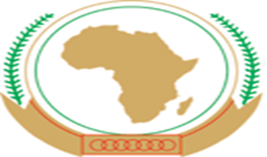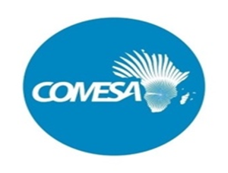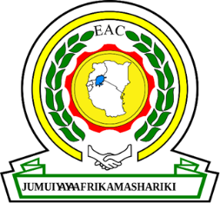 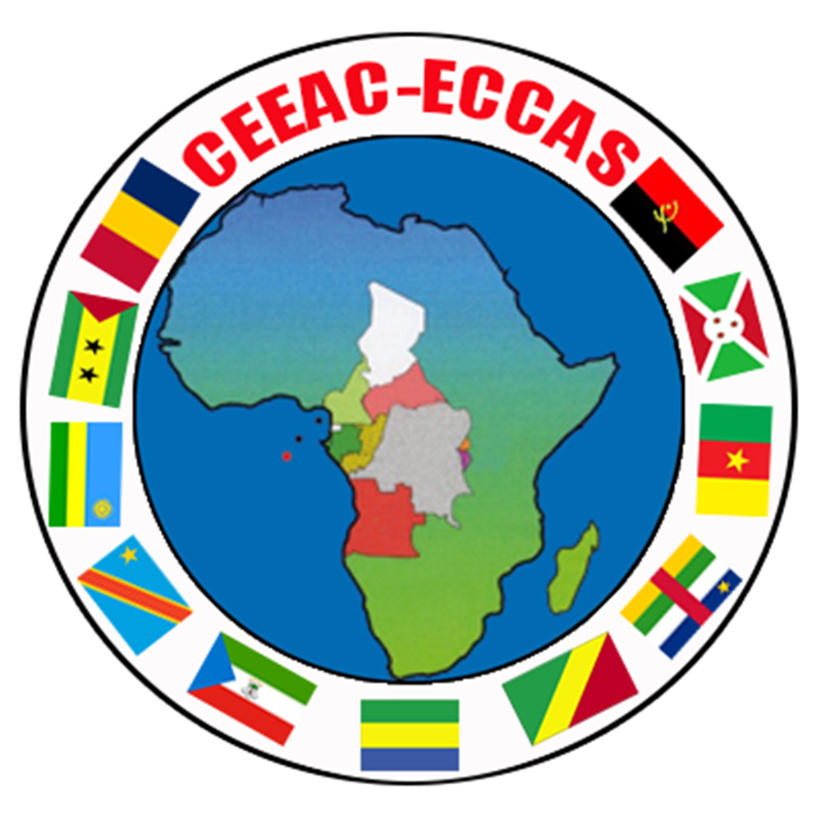 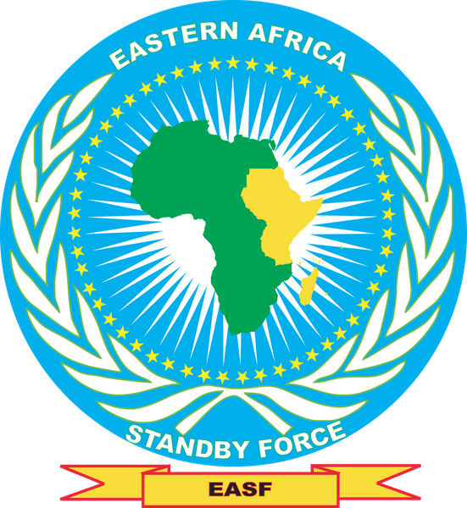 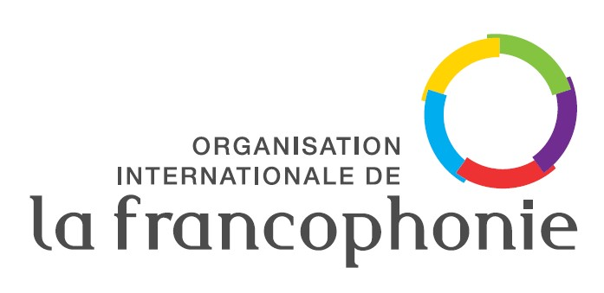

**JOINT COMMUNIQUE OF THE INTERNATIONAL ELECTION OBSERVATION AND ELECTORAL MISSIONS TO**

**THE REPUBLIC OF RWANDA GENERAL ELECTION OF JULY 2024**

1. **UPON** the invitation of the National Electoral Commission (NEC) of the Republic of Rwanda, the Election Observation Missions of the East African Community (EAC); the African Union (AU) jointly with the Common Market for Eastern and Southern Africa (COMESA); the Economic Community of Central African States (ECCAS); the Eastern Africa Standby Force (EASF) and the electoral mission of the International Organisation of la Francophonie (OIF) observed the General Election of Rwanda of July 2024.
2. **RECOGNISING** the commitment of the people of the Republic of Rwanda to build a State based on consensual and pluralistic democracy founded on power sharing, national unity and reconciliation, good governance, development, social justice, tolerance and resolution of problems through dialogue;
3. **MINDFUL** that the political and electoral system of Rwanda is designed to fulfill this commitment and having acquainted ourselves with the prevailing political and electoral environment and the context within which the people of Rwanda are exercising their democratic right to vote for their leaders; and
4. **HAVING** interactedwith various key stakeholders involved in the electoral process and witnessed the campaigns, voting, counting and tallying;
5. **OBSERVE** that:
6. the electoral, political and security environment in the Republic of Rwanda before,

during and immediately after the elections has been calm and peaceful;

1. the National Electoral Commission and other institutions responsible for managing

the electoral process have so far discharged their duty diligently in accordance with the electoral calendar.

1. **COMMEND** the Government of the Republic of Rwanda and the National Electoral Commission for successfully organizing and managing the electoral process thus far.
2. **CONGRATULATE** the people of Rwanda for exercising their democratic right to choose their leaders in a calm and peaceful manner.

Done in Kigali this 17th day of July, 2024:

|  |  |  |  |  |  |
| --- | --- | --- | --- | --- | --- |
| H.E. JORGE CARLOS DE ALMEIDA FONSECA  Head of Mission  AU/ - COMESA | RT. HON. RUHAKANA RUGUNDA  Deputy Head of Mission  AU/COMESA | CHIEF JUSTICE (EMERITUS)  DAVID K. MARAGA  Head of Mission  EAC | Hon MAHAMAT  BECHIR  OKORMI  Head of  Mission  ECCAS | AMB. KENNEDY MOKAYA  Head of Mission  EASF | RT. HON. MOHAMED BEAVOGUI  Head of Mission  OIF |