 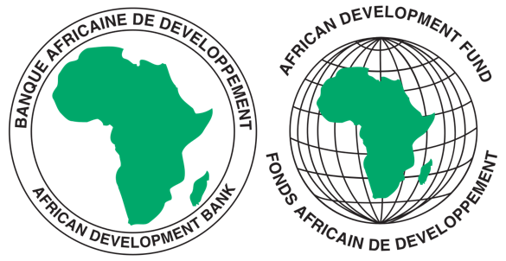

COMMON MARKET FOR EASTERN AND SOUTHERN AFRICA

**REQUEST FOR EXPRESSIONS OF INTEREST**

**SELECTION OF INDIVIDUAL CONSULTANTS**

REFERENCE NUMBER: CS/CSTRPSD/01/08/km

**CONSULTANCY SERVICES TITLE**: CONSULTANCY SERVICES TO DEVELOP A REGIONAL PHARMACOVIGILANCE AND COMMUNICATION STRATEGY FOR COMESA IN ALIGNMENT WITH OTHER REGIONAL ECONOMIC COMMUNITIES

**PROJECT NAME:** COMESA SUPPORT TOWARDS REGIONAL PHARMACEUTICAL

SECTOR DEVELOPMEMNT

**SECTOR:** INDUSTRIALISATION/PHARMACEUTICAL INDUSTRY

**GRANT NUMBER:** 2100155042033

**PROJECT ID:** P-Z1-BB0-008

1. This Request for Expression of Interest follows the General Procurement Notice for this Project that appeared in UN Development Business (UNDB online); on the African Development Bank’s Internet Website ([www.afdb.org](http://www.afdb.org)) and the COMESA Secretariat Website ([www.comesa.int](http://www.comesa.int)) on 10 February 2022.
2. The COMESA Secretariat has receiveda grant from the African Development Fundtowards the implementation of the COMESA Support Towards Regional Pharmaceutical Sector Development Project. The COMESA Secretariat intends to apply part of the proceeds of the grant to recruit an Individual Consultant **to Develop a Regional Pharmacovigilance and Communication Strategy for COMESA in Alignment with other Regional Economic Communities.**
3. The main objective of this consultancy is to develop a Pharmacovigilance Strategy and associated Monitoring, Evaluation and Accountability Plan to promote implementation of Pharmacovigilance programs in the COMESA region. The consultancy will focus on the health system and pharmaceutical industry in the COMESA region while leaning heavily on functional pharmacovigilance systems in Member States and globally. The strategy will be supported by a communication, visibility, stakeholder engagement and resource mobilisation strategy.
4. The Consultant is expected, among other things, to:
5. Develop an appropriate methodology for the assignment and outline it in the inception report;
6. Review the international, regional and sub regional policy, legal, regulatory, and institutional frameworks on pharmacovigilance to identify good practices, bottlenecks, and strengths.
7. Conduct a comparative analysis and benchmarking exercise with other successful frameworks and initiatives outside the region to identify gaps in policies, strategies and performance as well as draw reform lessons.
8. Develop a comprehensive regional Pharmacovigilance Strategy with elements such as capacity-building, resource mobilization, among others, for achieving a fully functional and sustainable medicine and medical products safety system.
9. Organize an expert group meeting to interrogate the COMESA Pharmacovigilance Strategy and the Communication and Visibility Strategy.
10. The COMESA Secretariat now invites eligible candidates to indicate their interest in providing these services. Interested Individual consultants must provide information indicating that they are qualified to perform the services (i.e., description of similar assignments, experience in similar conditions and availability of appropriate skills and qualifications).
11. The individual consultant should have a strong background in pharmacovigilance in Africa, and significant in-depth expertise and knowledge of health systems and pharmaceutical sector including policy developments on the continent and in the COMESA region.

Expressions of Interest shall be evaluated as follows:

1. Applicant’s Educational qualifications 30 points
2. Relevant Experience and skills 60 points
3. Experience in the African Region 10 points
4. Eligibility criteria, establishment of the short-list and the selection procedure shall be in accordance with African Development Bank’s “Procurement Framework for Bank Group Funded Operations” dated 2015, which is available on the Bank’s website at: <https://www.afdb.org/en/projects-and-operations/procurement/new-procurement-policy>. The Consultant will be selected under the Individual Consultant Selection (**ICS**) method.
5. Detailed description of the assignment including Terms of Reference defining the minimum technical requirements for the services can be downloaded free of charge from the COMESA Website on the link alongside this notice: [www.comesa.int](http://www.comesa.int)
6. Additional requests for information and clarifications can be made until 5 working days prior to the deadline at the following addresses: E-mail: [kmiti@comesa.int](mailto:kmiti@comesa.int); [s.mwesigwa@comesa.int](mailto:s.mwesigwa@comesa.int); [wsiduna@comesa.int](mailto:wsiduna@comesa.int)
7. **SUBMISSION OF APPLICATIONS**

Expressions of Interest bearing the subject: **“ Consultancy Services to Develop a Regional Pharmacovigilance and Communication Strategy for COMESA in Alignment with other Regional Economic Communities”** must be submitted as **ONE FILE** using the Expression of Interest Forms annexed to the Terms of Reference and must be emailed to the following addresses: E-mail: [kmiti@comesa.int](mailto:kmiti@comesa.int); [s.mwesigwa@comesa.int](mailto:s.mwesigwa@comesa.int); [wsiduna@comesa.int](mailto:wsiduna@comesa.int) **by 16:00hrs Zambia Time, on 30th August 2024**

NB: Physical submission of EOIs will not be accepted.